Shining shrimps project
January 22th, 2017
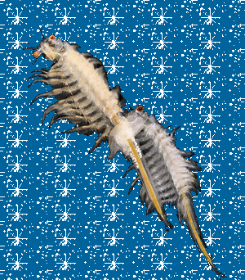
Blink, blink, blink
Helloooooo everyone !
As a part of Biosensors, a challenge of four weeks to make amazing projects about organisms and their sensors, we had the opportunity to work about the light and its relationship with organisms. First, you should know that light plays an important role for the most of organisms, whether they live on earth or in water.
Artemia salina - little brine shrimps living in lakes, usually food for fishes, are attracted by light and swim in its direction but also, could be repelled by it depending on moments (see a video demonstration here). More, this species possess three eyes with one special to detect light and its direction! This is why we asked ourselves this question:

How Artemia salina are sensible to light in comparison of an electronic sensor ?
First, to respond to this question, we tried to focus on different aspects of the Artemia salina movement to the light. We chose to observe their light intensity sensibility, which means how much Artemia salina can perceive light, and the time that they need to react.
Usually, new technologies invented by humans are inspired from nature, biological systems which already exist. Make comparisons could allow to improve our inventions. Our objective was to use an electronic sensor to see which one between shrimps and an electronic device is the best performer to detect light!
To decide between them, we tested them on four different luminosities (low, medium-low, medium-high, high). They would be plunged into the black, then exposed to a specific luminosity to observe their reaction, response time, as we told previously.
To realize our project, we followed this scientific approach:

Get samples > Preliminary tests > Realization of the set up > Experiments and replicates > Analyze raw data > Conclusion
To preserve the Artemia salina bought in an aquatic organisms shop, we prepared a salt water made home with love, by mixing 450 g of salt and 15 liters of water at 10°C in a big tray, then adding three drops of nutrients solution (Plankton liquid, you should try this is really tasty!).
The day before, we customized three jars of 1 L with black sheet to serve as small aquariums for the experiments. Why three ? Because to prove an hypothesis, you need to multiplicate your experiment to ensure the entire world that many similar results confirm your hypothesis. We call it replicate. Then, we also realized the setup to provide the light source: we used a LED strip with an Arduino Leonardo, which is actually an electronic device which could be managed by a computer and could sense/control objects in the physical world. You can admire our setup on the GIF below. With the same way, we made the electronic sensor.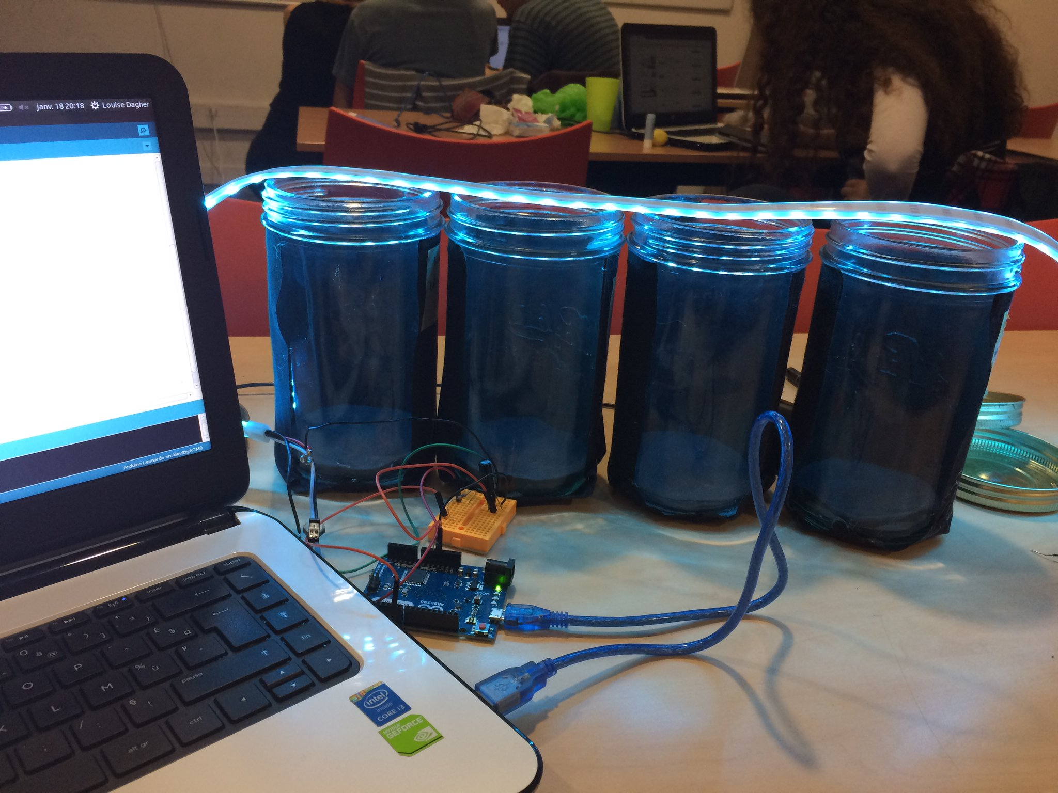
After this step, we began the experiments by putting shrimps into the black, then lighting and filming them. We did the same conditions with the electronic sensor.

By using the Tracker Software, we recorded the shrimps trajectory, frame by frame, and compared their position with the y axis, in order to know if the light wera attracting them, repulsing them, or either having no influence on them.
It was an exhaustive work, so we didn’t tracked the whole 7min of film, but only the first minutes, which represent almost 30 points, per shrimp.

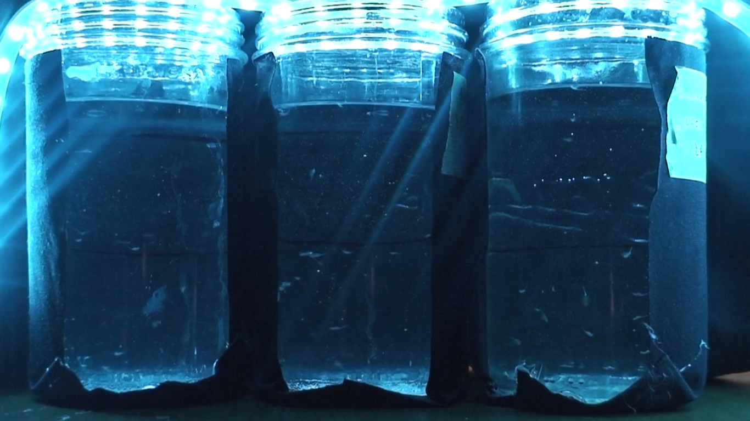
As results, we found that under a certain luminosity (~ 150 lux) the shrimps were repelled by the light, going down to the bottom of the jar ! This phenomenon exists and is called negative phototaxis. This is the same phenomenon as bats who do not like the light of the day. In contrary, they are attracted when light is over 240 lux. As explanation, we can suppose that these both phenomenons give an advantage to Artemia salina shrimps to better survive, such as to find food or anything else.
On the other hand, our range of 4 luminosities was too short to determine the sensibility of the electronic sensor. We saw that it response time is always the same whatever is the luminosity.
To put it in a nutshell dear readers, we have seen that Artemia salina is attracted to certain intensities of light and repulsed by the lowests. But what about higher intensities ? We let you discover that by yourself !
Furthermore, if you want more information and learn about scientific experiments made about it, you can consult this article !
And here is our Storify !
GitHub link here to all the resources needed for this project.
Presentation link here.
And if you want to know more about us and our project, you can visit/follow these Twitter pages : Louise, Nicolas, Clément, The Artemia salina project page, Biosensors page

